Reducing Pesticide Use in Human Dwelling Places

There are vulnerable people who are most likely to be exposed to chemicals which are used around our homes. These can include children, elderly and the immunocompromised. This can happen in schools, daycare centers, hospitals and backyards.
Pesticides are often used in these areas to manage pests such as rodents, insects, mites, plant diseases, bats, and weeds. People who are inexperienced tend to use these chemicals unwisely or incorrectly which can put people under risk as they can be harmful to human health. Every pesticide application must be planned to avoid exposure to untargeted organisms, especially sensitive individuals and the environment. Pesticide exposure can happen once (acute exposure) or repeatedly (chronic exposure) when a person comes into contact with a pesticide frequently. Since it is impractical to completely stop using pesticides, the goal is to reduce risk by minimizing the amount used and choosing the less toxic pesticide products. Integrated Pest Management (IPM) is a practice that can significantly minimize the amount of insecticide used while keeping the pest under control.

Integrated Pest Management
It is a holistic approach that advocates for the use of a combination of compatible tactics, including nontoxic approaches. Avoid relying too much on chemicals. Some pests can easily be dealt with using one or a combination of the ideas below:

- Correct Identification of the pest: Misidentification can result in treatments that are ineffective and unnecessarily leading to exposure of people to pesticides.
- Monitoring: are the numbers worrisome and many to warrant treatment. One can use sticky papers often sold by local agrochemical dealers and put them in areas where pests, if present, are likely to be.
- Sanitation: remove or make unavailable anything that can attract and favor pests, such as food and water
- Exclusion: Seal cracks and crevices to keep pests out. This works for pests such as spiders, millipedes, house crickets, flies, rodents, and bats.
- Mechanical control: Use nontoxic, low-risk methods, such as insect and rodent traps.

Let us protect ourselves to avoid exposure to pesticides. See below the absorption rates of different parts of the body.
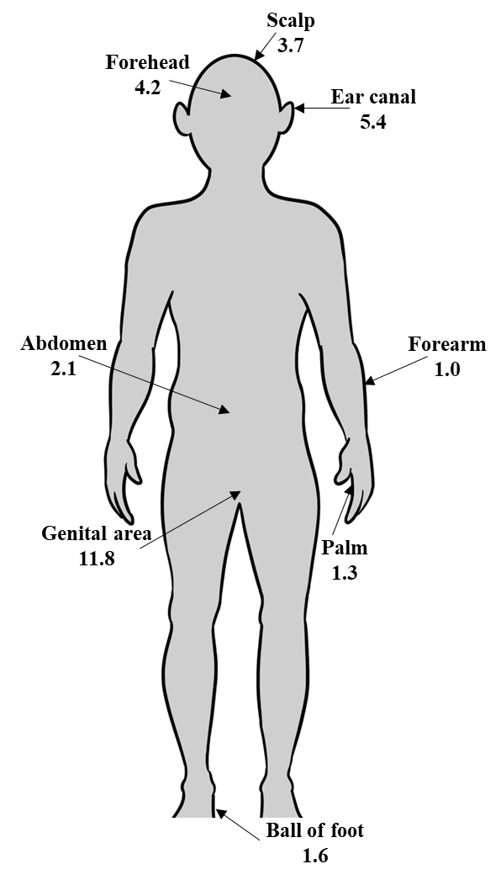
Figure 1: Absorption rates of different parts of the body

